# Test Cases – Zac’s portion

|  |  |  |  |  |  |  |  |
| --- | --- | --- | --- | --- | --- | --- | --- |
| 8 | Test if the home page button on the tourist user type home page links back to the website home page | URL for homepage | Home page loaded | Loaded home page | Loaded home page | 24/10/17 | Pass |
| 9 | Test if the home page button on the businessman user type home page links back to the website home page | URL for homepage | Home paged loaded | Loaded home page | Loaded home page | 24/10/17 | Pass |
| 10 | Test if the text boxes on the login/register page can be inputted into by the user | Loading login page | Text boxes containing text that has been inputted into them | Text boxes allowing text to be inputted | Text boxes allowed text to be inputted | 24/10/17 | Pass |

# Test Evidence Serial 8 – Selecting the home page button on the tourist home page

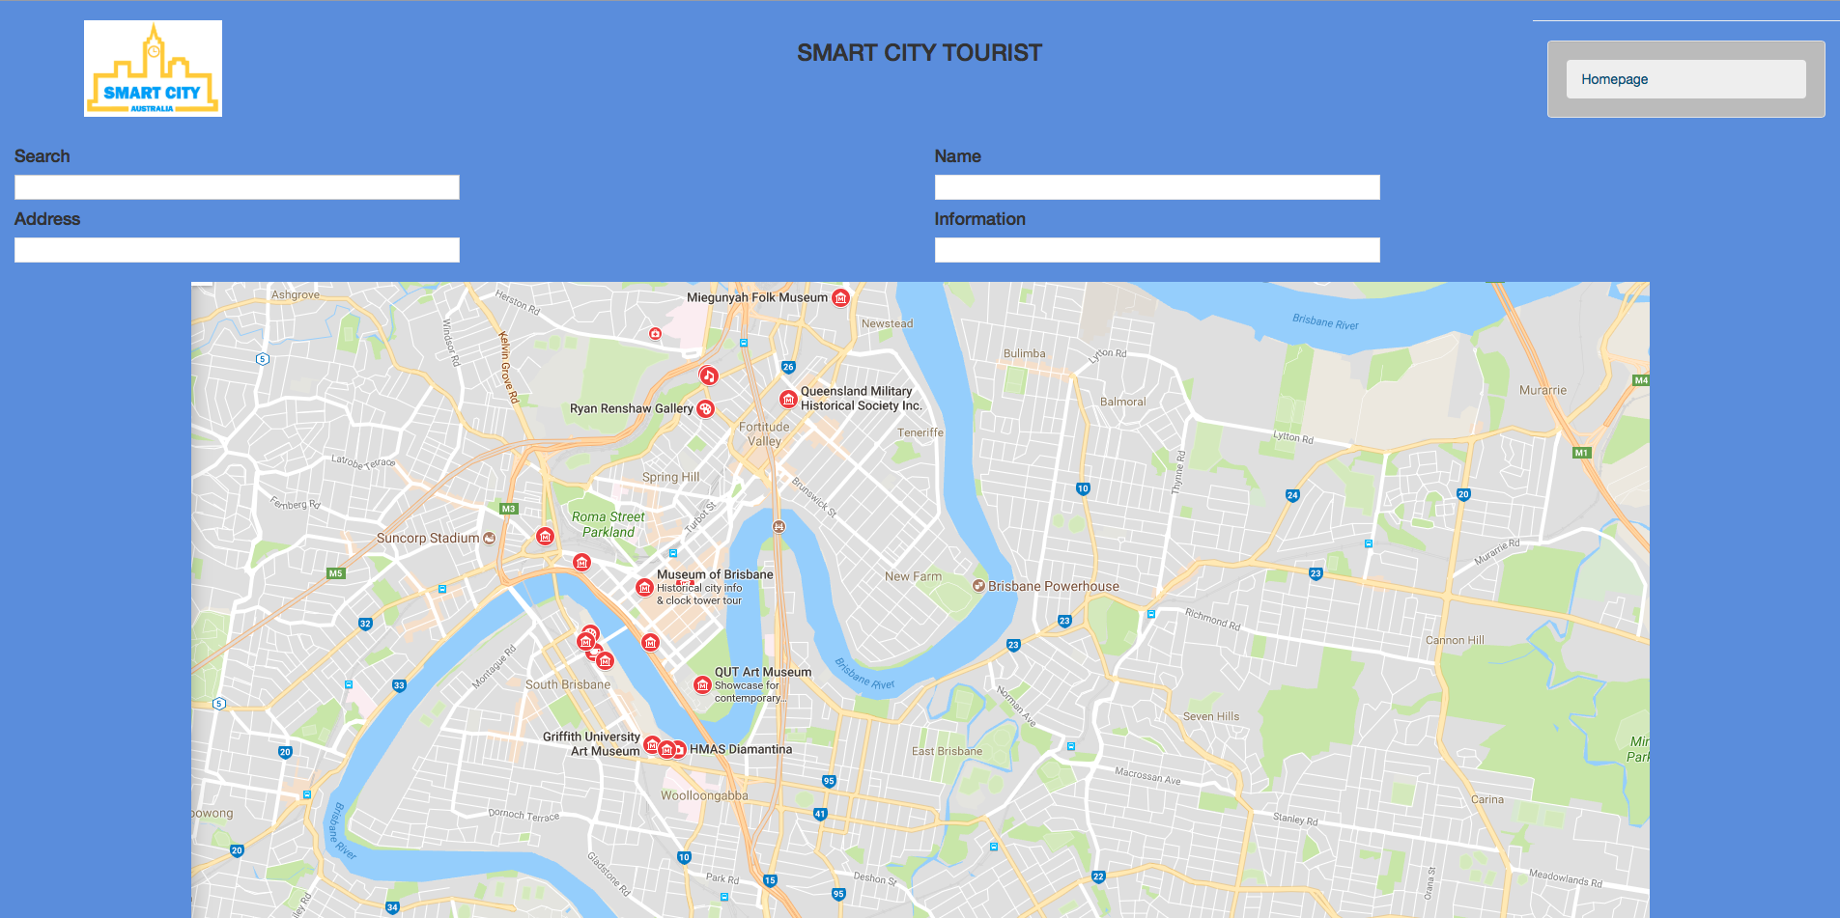

# Home page loaded correctly



# Test Evidence Serial 9 – Selecting the home page button on the business home page

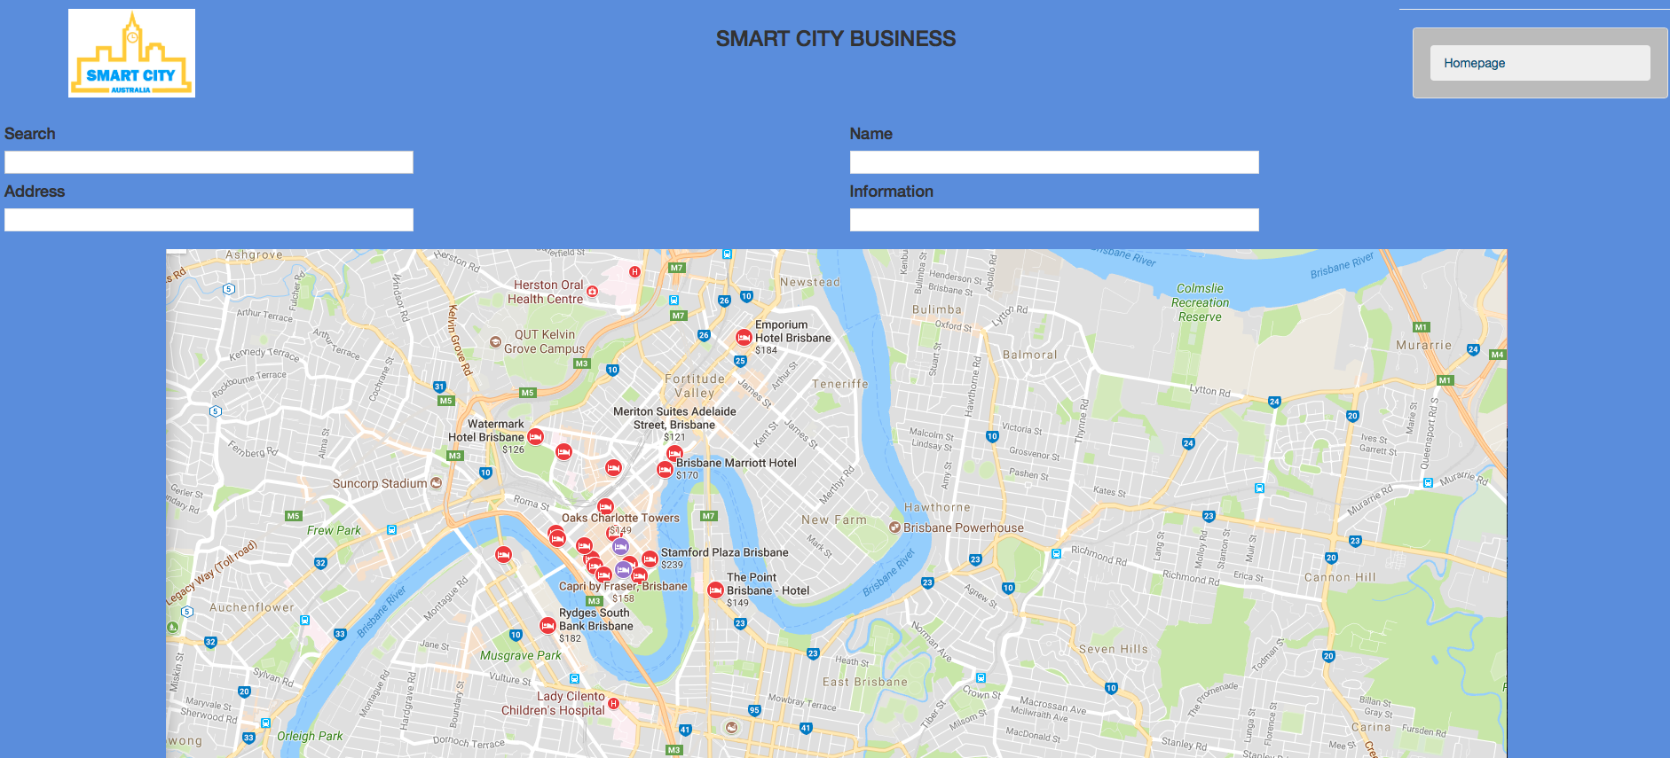

# The home page loaded correctly



# Test Evidence Serial 10 – Testing if text boxes on the login/register page can be inputted by the user

